Dear BW families,

**Last week:**  
It’s been a great 3 weeks back! We had picture day and Covid testing on the same day, our first PTA meeting, a parent volunteer meeting and then a fire drill on Friday! What a busy week. The students handled it all brilliantly. A big shout out to our Fire Marshall, Olivia, who practiced her communication skills while calling in our fire drill to School Police.

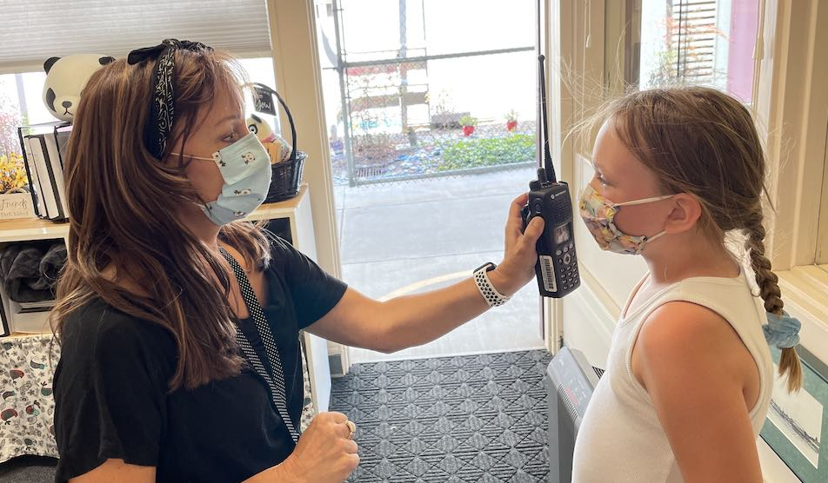 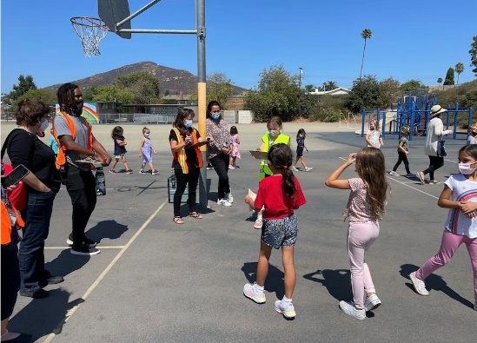

**This week:**  
We're starting off Week 4 with a visit from our district leadership team. Interim Superintendent, Lamont Jackson, Chief of Staff, Sofia Roditti, and our Area Superintendent, Monika Hazel. I’m excited to share with them our Covid safety measures and our instructional focus for the 21-22 school year: Communication through Literacy.

**BW 21-22 instructional focus: Communication through Literacy**  
Learn more about our 21-22 instructional focus: Communication through Literacy in my [Curriculum Night video (click here)](http://track.spe.schoolmessenger.com/f/a/H7dO1iJ8vh6vDLgfOx5HMg~~/AAAAAQA~/RgRjKRFgP0QcaHR0cHM6Ly95b3V0dS5iZS9pZzZBb0h1ajBBZ1cHc2Nob29sbUIKYUDg3Udh4XxmJFIRTUFocmVuc0BzYW5kaS5uZXRYBAAAAAE~). In the video I explain the What, Why and How of our Instructional Focus. Be on the lookout throughout the year for more evidence of this focus in Newsletters, on our [website (click here)](http://track.spe.schoolmessenger.com/f/a/gYUxVk8ytjVFZemzqe9qfA~~/AAAAAQA~/RgRjKRFgP0QzaHR0cHM6Ly9iZW5jaGxleXdlaW5iZXJnZXIuc2FuZGllZ291bmlmaWVkLm9yZy9uZXdzVwdzY2hvb2xtQgphQODdR2HhfGYkUhFNQWhyZW5zQHNhbmRpLm5ldFgEAAAAAQ~~), [Youtube channel (click here)](http://track.spe.schoolmessenger.com/f/a/BOh0eLTfRQV1-kBWIzoSOw~~/AAAAAQA~/RgRjKRFgP0Q4aHR0cHM6Ly93d3cueW91dHViZS5jb20vY2hhbm5lbC9VQ0JaTWNGdXhwenFRenpTX1FvQ1N5Q3dXB3NjaG9vbG1CCmFA4N1HYeF8ZiRSEU1BaHJlbnNAc2FuZGkubmV0WAQAAAAB) and on Twitter ([@BenchleyElem](http://track.spe.schoolmessenger.com/f/a/uWSemuNKfSPMEQayXxv2Nw~~/AAAAAQA~/RgRjKRFgP0QoaHR0cHM6Ly90d2l0dGVyLmNvbS9iZW5jaGxleWVsZW0_bGFuZz1lblcHc2Nob29sbUIKYUDg3Udh4XxmJFIRTUFocmVuc0BzYW5kaS5uZXRYBAAAAAE~))

**Be a Panda Parent with Heart:**  
Please help us keep our little pandas safe by following these traffic rules

* Drive slowly (5 MPH) when near school
* Do not make U-turns on Gloria Lake or Twin Lake Dr.
* Cross the street at crosswalks only, not in the middle of the block in front of traffic
* Use the loading zones (white curbs) for loading and unloading only. Do not park and walk students to the gates while in loading zones.
* Pull all the way forward when in loading zones
* Do not double park
* Do not block our neighbor’s driveways

Have a fantastic Sunday evening!  
Mindy Ahrens  
Principal  
Benchley Weinberger Elementary